**PROJECT REPORT**

**On**

JOB PORTAL

Submitted in partial fulfillment of the requirement for the Course BEE (22CS026) of

**COMPUTER SCIENCE AND ENGINEERING**

**B.E. Batch-2022**

**in**

**Jan -2025**



**Under the Guidance of**

**Submitted By**

**Mr. Rahul Singh Rajput Prerana Thakur**

**Trainer Roll No. 2210992085**

**Prachi Jain**

**Roll No. 2210992054**

**Pawan Gambhir Roll No. 2210992035**

**DEPARTMENT OF COMPUTER SCIENCE AND ENGINEERING**

CHITKARA UNIVERSITY

**PUNJAB**

# CERTIFICATE

This is to be certified that the project entitled “Job Portal” has been submitted for the Bachelor of Computer Science Engineering at Chitkara University, Punjab during the academic semester June 2024 - December 2024 is a bona fide piece of project work carried out by Pawan Gambhir 2210992035, Prerana Thakur 2210992085 and Prachi Jain 2210992054 towards the partial fulfillment for the award of the course Integrated Project (CS 203) under the guidance of Mr. Rahul and supervision.

### Sign. of Project Guide:

Mr. Rahul Singh Rajput

# CANDIDATE’S DECLARATION

We, Pawan Gambhir 2210992035, Prerana Thakur 2210992085, Prachi Jain 2210992054**,** B.E.-2022 of the Chitkara University, Punjab hereby declare that the Integrated Project Report entitled **“Job Portal”** is an original work and data provided in the study is authentic to the best of our knowledge. This report has not been submitted to any other Institute for the award of any other course.

|  |  |  |
| --- | --- | --- |
| **Sign. of Student 1** | **Sign. of Student 2** | **Sign. of Student 3** |
| Pawan Gambhir | Prachi Jain | Prerana Thakur |
| ID No 2210992035 | ID No 2210992054 | ID No 2210992085 |

**Place: Punjab Date: 08-10-**

**2024**

# ACKNOWLEDGEMENT

It is our pleasure to be indebted to various people, who directly or indirectly contributed to the development of this work and who influenced my thinking, behavior and acts during the course of study.

We express our sincere gratitude to all for providing me an opportunity to undergo Integrated Project as the part of the curriculum.

We are thankful to Mr. Rahul for his support, cooperation, and motivation provided to us during the training for constant inspiration, presence and blessings.

We also extend our sincere appreciation to ***Mr. Rahul*** who provided his valuable suggestions and precious time in accomplishing our integrated project report.

Lastly, we would like to thank the almighty and our parents for their moral support and friends with whom we shared our day-to day experience and received lots of suggestions that improve our quality of work.

|  |  |  |
| --- | --- | --- |
| Pawan Gambhir | Prachi Jain | Prerana Thakur |
| ID No 2210992035 | ID No 2210992054 | ID No 2210992085 |

# Table of Contents

|  |  |  |
| --- | --- | --- |
| **S. L. No.** | **Topics** | **Page No.** |
| 1 | Abstract | 6 |
| 2 | Introduction | 7 |
| 2.1 | Background | 7 |
| 2.2 | Problem Statement | 7 |
| 3 | Software and Hardware Requirement Specification | 8 |
| 3.1 | Methods | 8 |
| 3.2 | Programming/Working Environment | 8 |
| 3.3 | Requirements to Run the Application | 9 |
| 4 | Database Analysing, Design and Implementation | 10 |
| 5 | Program’s Structure Analysing and GUI Constructing | 11 |
| 6 | Code-Implementation and Database Connections | 12 |
| 7 | Limitations | 13 |
| 8 | Conclusion | 13 |
| 9 | Future Scope | 14 |
| 10 | Bibliography/References | 14 |

1. **Abstract/ Keywords**

**Abstract:** This project aims to develop a full-stack job portal designed to facilitate efficient job searching for job seekers and help employers find the ideal candidates based on qualifications, experience, and skill sets. The backend of the system has been developed to manage job listings, user profiles, and application tracking with a scalable and secure architecture. It also incorporates advanced search and filtering mechanisms to enhance user experience.

### Keywords:

Job Portal

Backend Development Job Matching

User Profiles Application Tracking Full-Stack

Scalable Architecture Secure Data Handling

# Introduction to the project

In today’s competitive job market, finding the right job or the ideal candidate can be a challenging and time- consuming process. Our job portal aims to bridge this gap by offering an efficient, user-friendly platform designed to streamline job searches and recruitment efforts.

The primary purpose of our job portal is to connect job seekers with suitable job opportunities and help employers identify and hire the best candidates based on their qualifications, experience, and skill sets. By leveraging advanced search algorithms, intuitive user interfaces, and comprehensive job matching features, our platform seeks to make the job search and recruitment process more efficient and effective for both job seekers and employers.

## Background

In today’s fast-evolving job market, both job seekers and employers face several challenges. Job seekers often struggle to find suitable job openings that align with their skills and qualifications, while employers find it difficult to locate and hire the most qualified candidates from a sea of applicants. Existing job portals provide limited search capabilities and often lack personalization, resulting in inefficient hiring and job searching processes.

This project aims to address these issues by building a robust and scalable job portal that connects job seekers and employers more efficiently. The portal is designed to streamline the recruitment process, offering advanced job matching and profile management features, all managed through a secure backend system.

## Problem Statement

### For Job Seekers:

* + - Difficulty in finding relevant job opportunities amidst overwhelming listings.
    - Lack of personalized job recommendations.
    - Inefficient and time-consuming application processes.

### For Employers:

* + - Inability to easily identify candidates who match specific job criteria.
    - High costs and delays in the recruitment process.
    - Limited insights into candidates' qualifications and skills.

# Software and Hardware Requirement Specification

## Methods

* + - **Backend Development:** The backend of the portal has been built to handle key operations such as job listings management, user authentication, profile updates, and application tracking. The backend architecture supports both job seekers and employers with appropriate role-based access control.
    - **Database Integration:** The system uses a non-relational (NoSQL) database to store user data, job listings, and application records efficiently.
    - **Authentication and Security:** Secure login mechanisms and role-based access are implemented to ensure data protection, and encryption techniques are used to safeguard sensitive information.

## Programming/Working Environment

### Programming Languages:

**Backend:** Node.js (JavaScript), or similar technologies based on the specific backend framework selected.

* + - **Database: NoSQL (MongoDB)** for more flexible data handling.
    - **Server Environment: Local Development:** Using Node.js or Python environments for testing.

### Development Tools:

**Version Control:** Git and GitHub for code collaboration and version tracking.

**API Development Tools:** Postman for testing and documenting APIs.

**Package Management:** npm (Node Package Manager) for managing dependencies. Studio Code as our primary code editor.

## Requirements to Run the Application

### Software Requirements:

**Operating System:** Any modern OS (Windows, macOS, or Linux) that can run the selected server and database environments.

### Development Tools:

Node.js runtime for JavaScript-based backend projects. A suitable database management system (MongoDB).

### Hardware Requirements: Local Machine Specifications:

Minimum 4GB RAM (8GB recommended).

2 GHz dual-core processor or better for smooth backend server execution. Adequate disk space for storing development files, libraries, and the database.

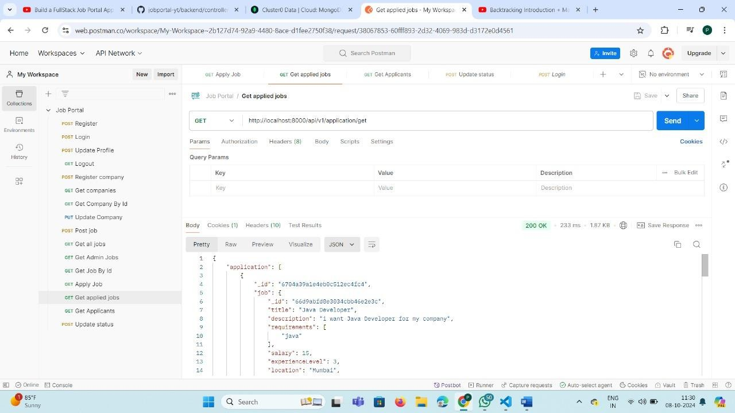

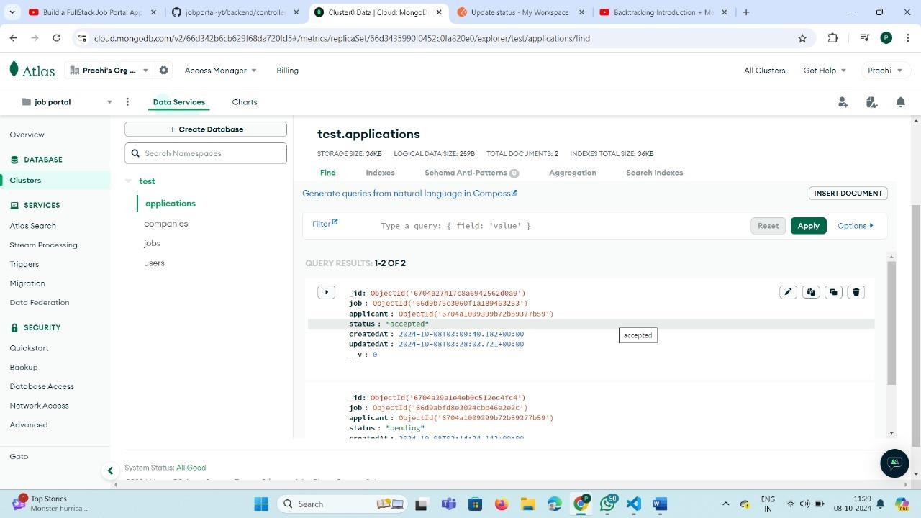

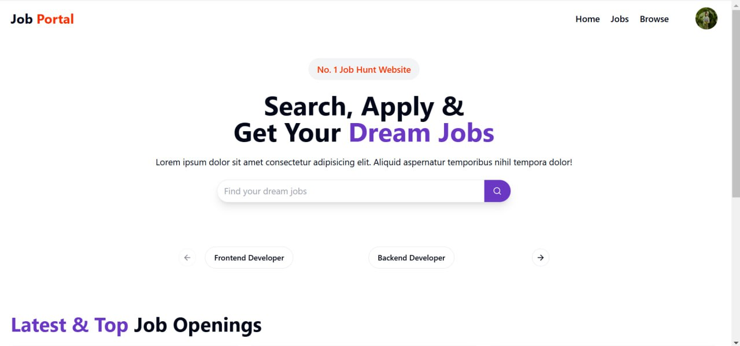

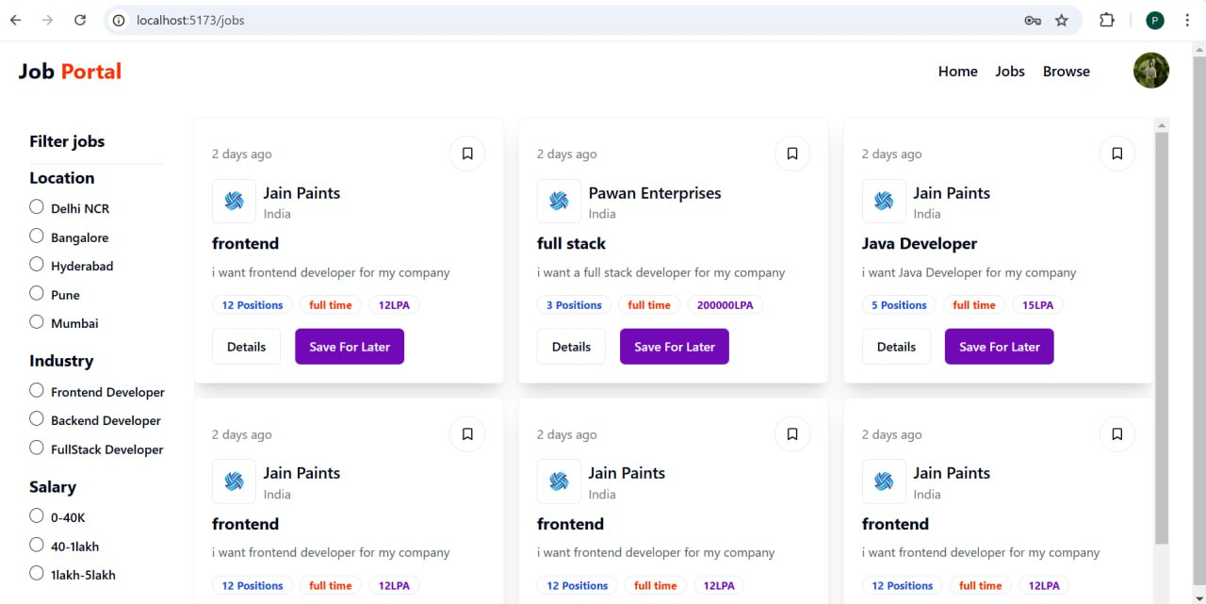

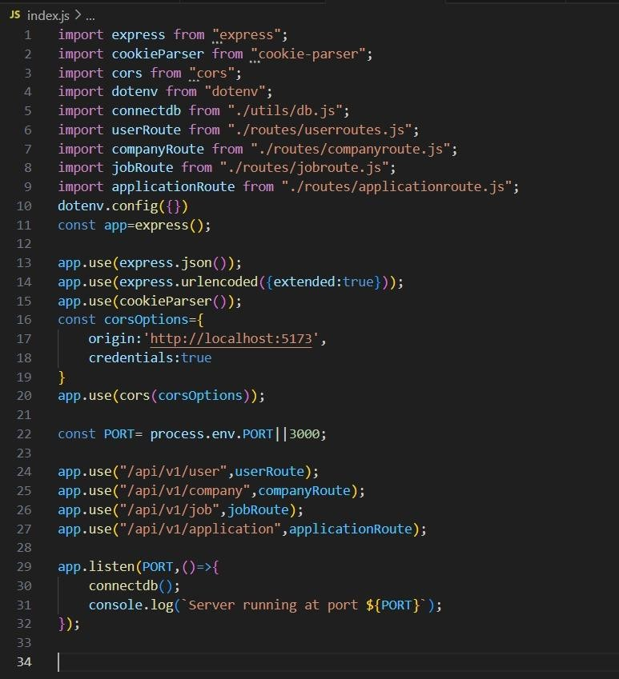

* The application is currently designed for small to medium-sized datasets, requiring optimization for larger databases.
* Limited support for real-time notifications for users and employers.
* No payment integration for premium job postings.
* Currently supports only English, limiting its reach to non-English speakers.

# Conclusion

The job portal project demonstrates the effective use of the **MERN stack** in building a comprehensive full-stack web application that addresses key pain points in the job search and recruitment process. By allowing companies and job seekers to interact seamlessly on a single platform, the system enhances the overall experience for both parties. The application leverages **MongoDB** for scalable data storage, **Express.js** and **Node.js** for backend functionality, and **React** for a dynamic and responsive frontend user interface.

On the backend, the job portal provides a scalable and efficient solution for managing recruitment processes, offering secure authentication, seamless API integration, and efficient database management. Future enhancements are aimed at scaling the system for larger datasets and incorporating **real-time features** such as live notifications and real-time application tracking to further improve the platform's functionality.

# Future Scope

* + Optimize for larger datasets and multi-threaded operations to improve scalability.
  + Integrate real-time job notifications and application status updates using Web Sockets.
  + Strengthen authentication and authorization mechanisms for enhanced security.
  + Implement multi-language support to attract a diverse user base.
  + Add real-time notifications for job updates and applications.
  + Integrate payment gateways for premium features such as highlighted job posts.

# Bibliography/References

* + Brown, S., 2021. 'Asynchronous Processing in Node.js: Impacts on Web Applications,' Computing Systems Journal, 8(2), pp. 150-165.
  + Jones, A., & Keller, P., 2020. 'The Shift to Web-Based Financial Management Tools,' International Journal of Digital Finances, 5(1), pp. 45-55.
  + Lamb, R., & Kling, R., 2003. 'Reconceptualizing Users as Social Actors in Information Systems Research,' MIS Quarterly, 27(2), pp. 197.
  + Thompson, L., & Wang, R., 2022. 'React Framework in Modern Web Applications,' Journal of Web Technologies, 9(1), pp. 85-102.4, 17-22, etc].